Safety Glasses

## http://capricornsafety.co.in/images/safety-glasses/1.jpg http://capricornsafety.co.in/images/safety-glasses/2.jpg http://capricornsafety.co.in/images/safety-glasses/3.jpg

## UVEX X ONE UVEX X TREND UVEX i-3 .9190

## http://capricornsafety.co.in/images/safety-glasses/4.jpg http://capricornsafety.co.in/images/safety-glasses/5.jpg http://capricornsafety.co.in/images/safety-glasses/6.jpg

## UVEX PHEOS 9192 UVEX SUPER FIT UVEX 9301

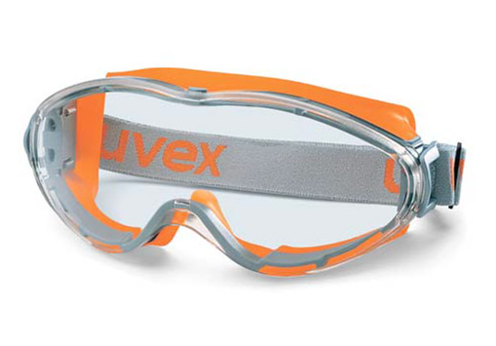 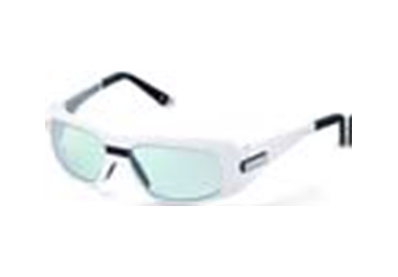 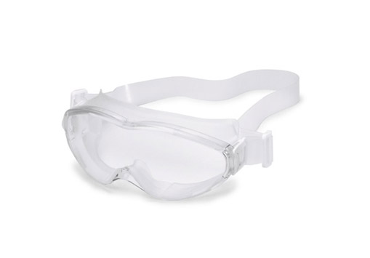

## UVEX ULTRASONIC 9302 LASER GOGGLES AUTOCLAVABLE GOGGLES

# Accessories

## http://capricornsafety.co.in/images/safety-glasses/10.jpg http://capricornsafety.co.in/images/safety-glasses/11.jpg http://capricornsafety.co.in/images/safety-glasses/12.jpg

### UVEX CLEANING STATION SPECTACLE POUCH THREAD